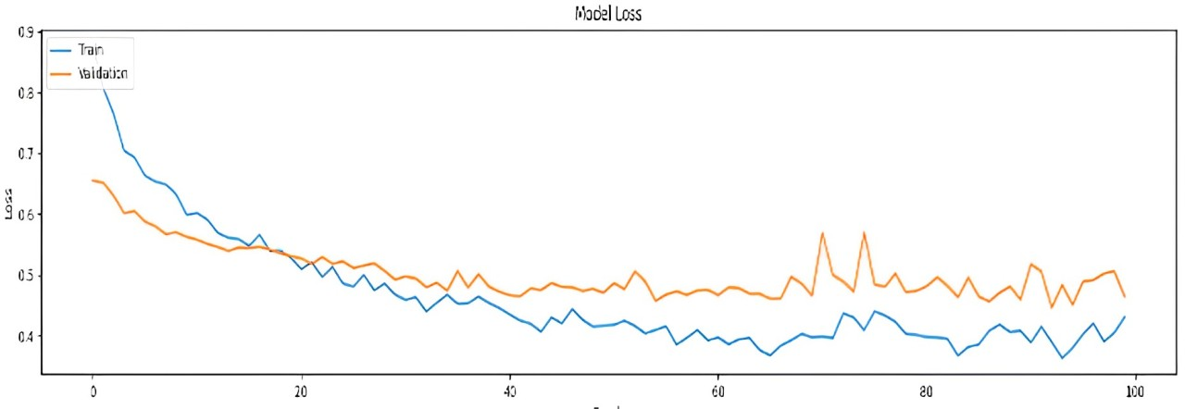
Model Loss
Loss
0.9
0.8
0.7
0.6
0.5
0.4
0 20 40 60 80 100
Train
Validation

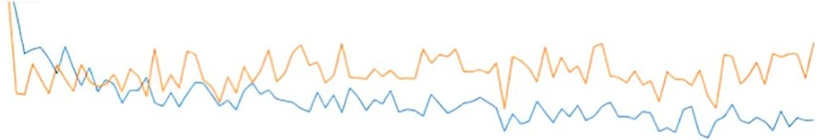
0.8
0.7
0.6
0.5
0.4
0.3
Train
Validation
Model Loss
Loss
0 20 40 60 80 100

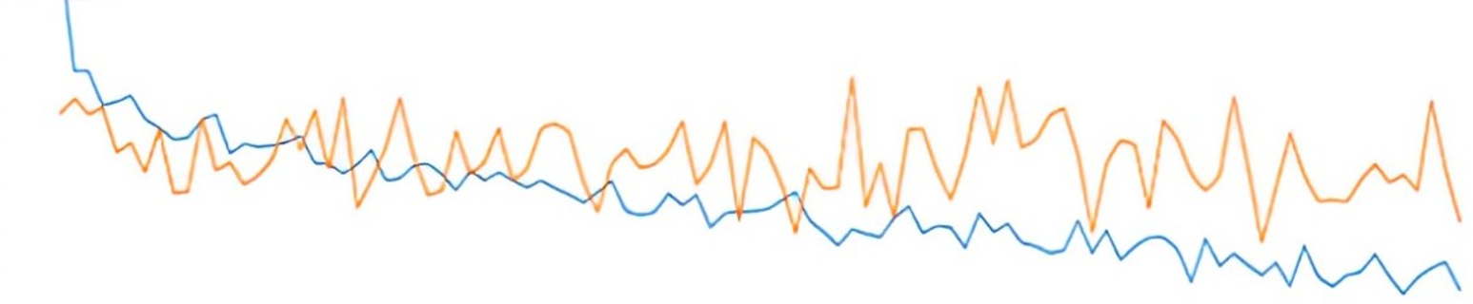
Model Loss
Loss
0.8
0.7
0.6
0.5
0.4
0.3
0 20 40 60 80 100
Train
Validation
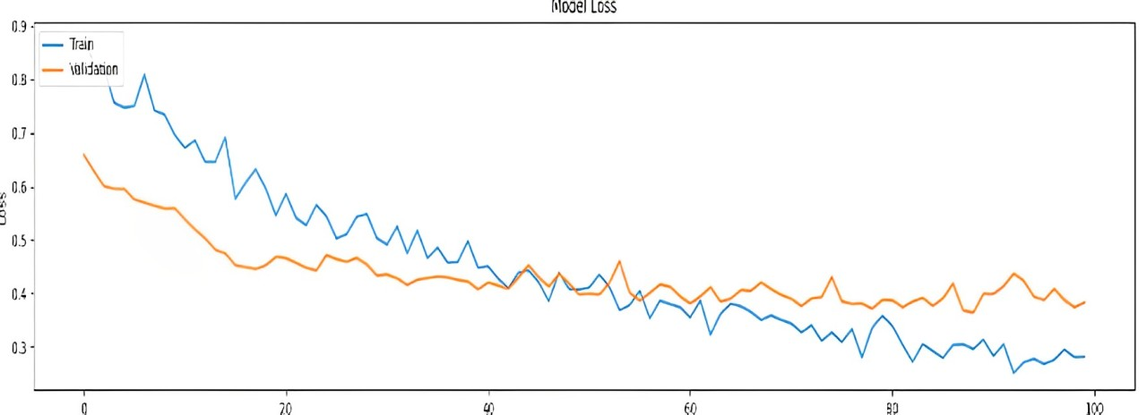
0.9
0.8
0.7
0.6
0.5
0.4
0.3
0 20 40 60 80 100
Train
Validation
Model Loss
Loss

